Certificate of Examination
The Piedmont Equine Practice is pleased to provide pre-purchase examinations. Please acknowledge that a pre-purchase examination reflects the health and soundness of the horse on the day of the evaluation and is no guarantee of future soundness and suitability.

Place of examination: Seller's farm, Reva, Virginia.
Date of examination: 8 June 2022.
Name of purchaser: Michael Newman
Address: 16 Nason Hill Lane
Sherborn, MA 01770
Telephone: 617-566-7975
Name of seller: Jill Marshall
Address: 6061 Griffinsburg Road
Reva, VA 22735

Name of horse: Une Etoile de L'Eclypse
Age: 15 years reported.
Breed: Belgian Warmblood.
Sex: Mare.
Color: Bay
Microchip: 981100002303231
Markings: Blaze. Stockings left fore and both hind. Coronet right fore.
Height: 17 hands approximately. Not measured.
Weight: 1300# approximately. Not weighed.
Intended Use: Fox hunting first field with Norfolk Hunt.
Past Use: 1.5 meter jumper with prior owner. Current owner has had for one year. In that time she has fox hunted twice weekly as a huntsman's horse for Jeff Woodall at Rappahannock. Seller reports no lameness or health issues and no joints injected in the time frame she has had the horse.

Physical Examination:
Temperature: 99.9.
Ophthalmic: Right eye focal white area in the iris just ventral to the pupil. Both eyes otherwise within normal limits.
Cardiovascular: Within normal limits at rest and recovering from exercising.
Respiratory: Within normal limits at rest, with a re-breathing bag, and while observed exercising on the longe.
Digestive: Teeth have enamel points—needs floating. Otherwise within normal limits and consistent with the stated age. Possible scar around the umbilicus, suggesting umbilical hernia repair as a weanling.
Dermatologic: Within normal limits.
Nervous system: Within normal limits.
Reproductive: Normal externally. Not examined internally.

Musculo-skeletal Examination:
Left forelimb: Mild effusion in the fetlock joint.
Right forelimb: Mild effusion in the fetlock joint.
Left hind limb: Moderate effusion in the digital tendon sheath. Positive Churchill test (an indicator of hock pain).
Right hind limb: Moderate effusion in the digital tendon sheath. Small chronic wound plantar metatarsus (back of the cannon bone area) with associated fibrosis, resulting in a mildly enlarged tendon area. No pain on palpation of this area.
Body: Within normal limits. Good range of motion in the neck, back, and lumbo-sacral joint.
Hoof tester examination: Reactive at the toe in both forelimbs. No other abnormal responses.
Shoeing: Rim shoes all around. No clips. Horse was shod yesterday.

Moving Examination:
Observed on an uneven grass surface. Sound in hand on a straight line. Mild (grade 1 on a 1 to 5 scale) right fore lameness circling to the right.

Flexion Tests:
Left forelimb: Negative lower limb and upper limb flexion tests.
Right forelimb: Mild positive lower limb, negative upper limb flexion tests.
Left hind limb: Negative lower limb, upper limb, and cross flexion tests.
Right hind limb: Negative lower limb, mild positive upper limb and cross flexion tests.

Radiographic Examination:
Front feet: Multiple synovial invaginations in the left fore distal navicular border. Otherwise within normal limits. Small bone spurs in both front pastern joints.
Front fetlocks: Within normal limits.
Hind fetlocks: Within normal limits.
Hocks: Slight arthritic change in the tarso-metatarsal joint of both hocks.
Stifles: Slight arthritic change in both stifles.

Endoscopy:
Not requested by purchaser.

Laboratory Tests:
Drug screen: Blood drawn and will be held for 30 days.
CBC: No significant abnormalities.
Chemistry: No significant abnormalities.
Coggins: pending.

Conclusion of Examination:

On the day examined, Une Etoile de L'Eclypse was serviceable for the intended use. The radiographic findings are all mild, and in a 15 year old warmblood with her performance history, do not significantly increase the risk of future lameness.

Thank you for the opportunity to examine Una prior to purchase. Please feel free to contact me if you have any questions about my findings or conclusions.

Sincerely,
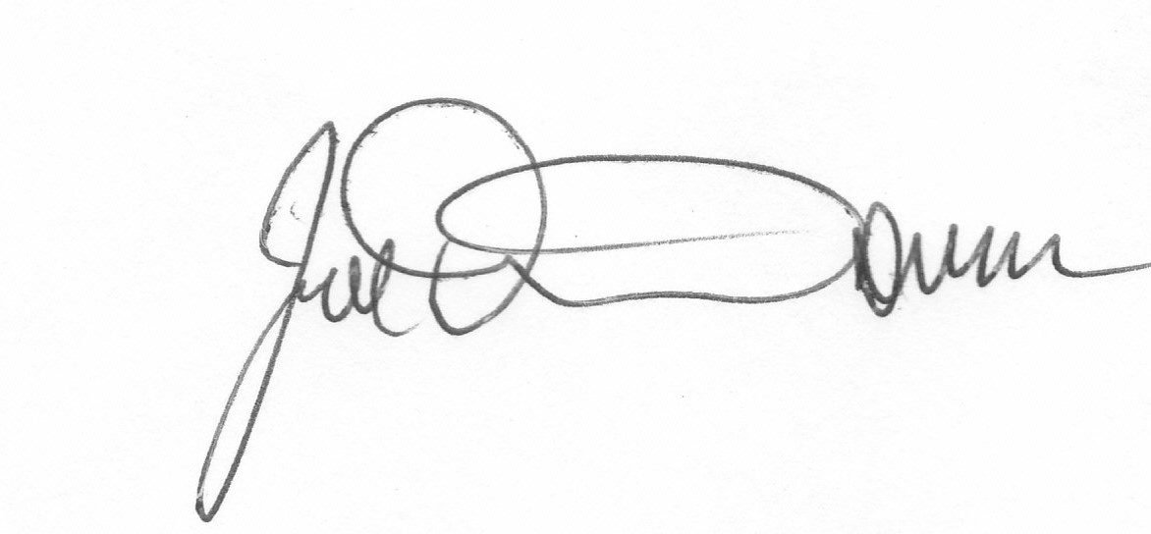
Joseph F. Davis, Jr., D.V.M.

