# Signs

Upon review we find that many signs required for our agricultural use are prohibited without a special permit. We also took a trip down Sandy Valley road and observed many signs that do not comply. The sign ordinance appears to be selectively enforced or not enforced at all.

**Other Signs on Sandy Valley Road**

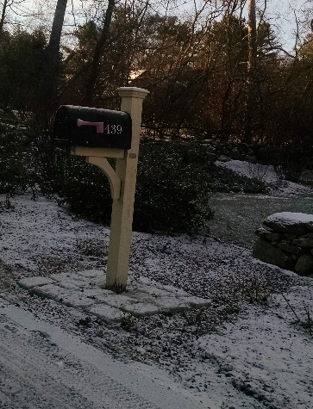 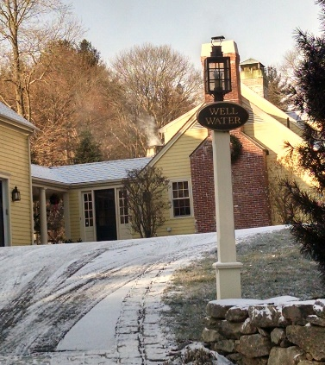

“Well Water” is not an allowed type of sign; more than maximum number of signs allowed.

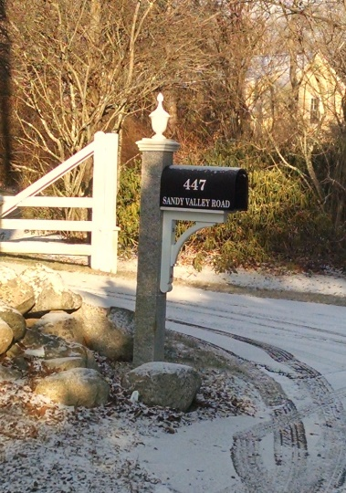 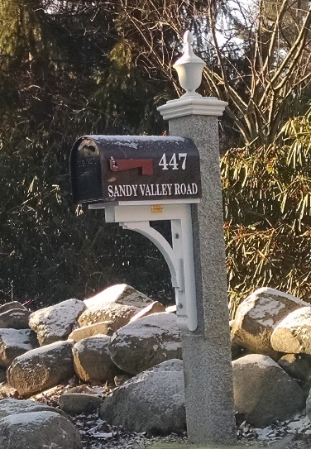

Sign (mailbox) too large; more than maximum number of signs allowed.

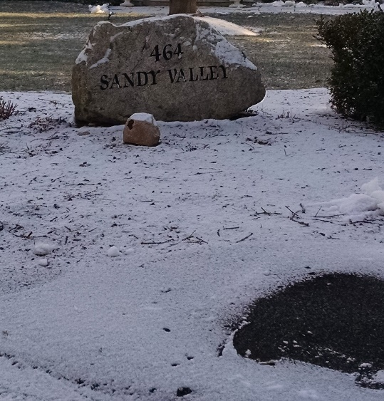

Sign too large; more than maximum number of signs allowed.

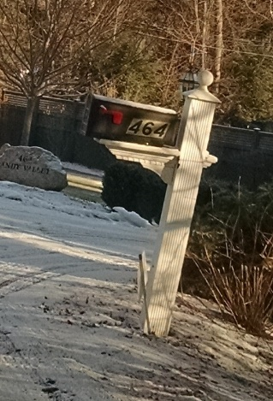 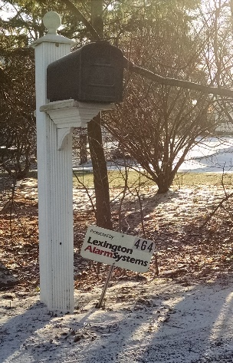

Alarm sign is not an allowed type; more than maximum number of signs allowed.

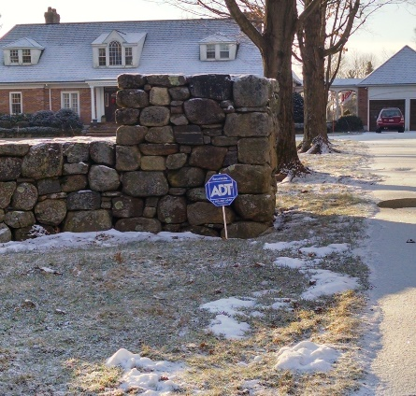

Alarm sign is not an allowed type; more than maximum number of signs allowed.

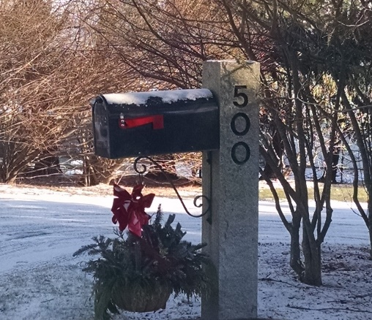

Sign (mailbox) too large.

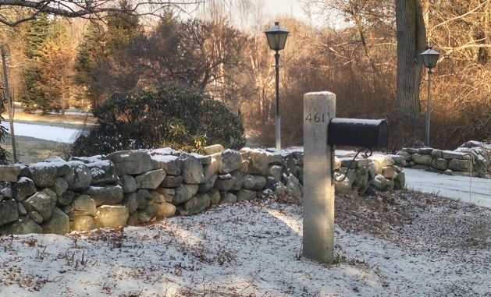

Sign (post) too large; more than maximum number of signs allowed.

**Signs on our property**

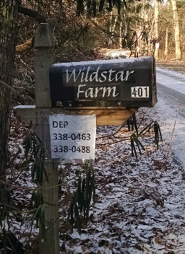

Sign (mailbox) too large.

DEP sign is not an allowed type but it is required by law; size exceeds what’s allowed by town bylaw; contributes to total number of signs, which exceeds what’s allowed by town bylaw.

.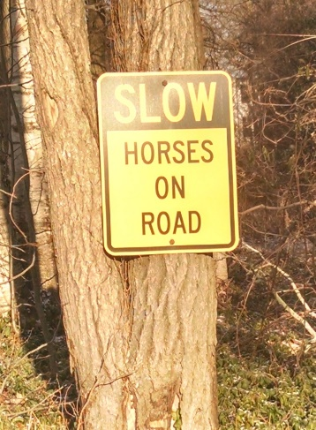

Safety sign; size exceeds what’s allowed by town bylaw; directly related to our commercial agricultural business; contributes to total number of signs, which exceeds what’s allowed by town bylaw.

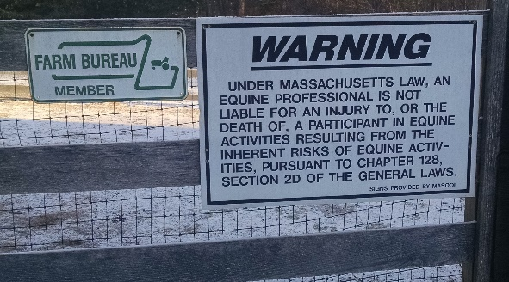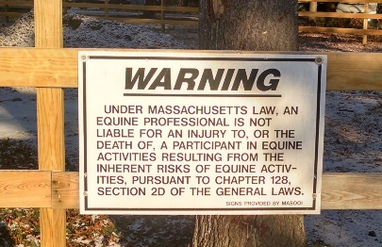

Neither sign is an allowed type but warning sign is required by our insurance and exceeds what’s allowed by town bylaw; directly related to our commercial agricultural business; contribute to total number of signs, which exceeds what’s allowed by town bylaw.

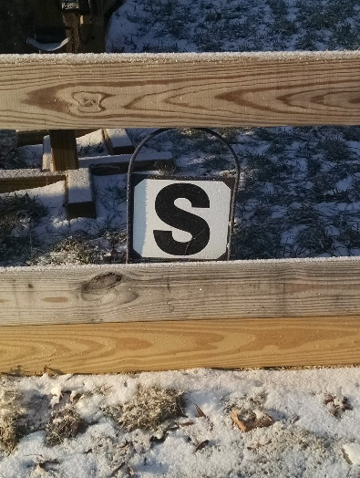

8 ring markers required for dressage riding done by our boarders; directly related to our commercial business; contribute to total number of signs, which exceeds what’s allowed by town bylaw.

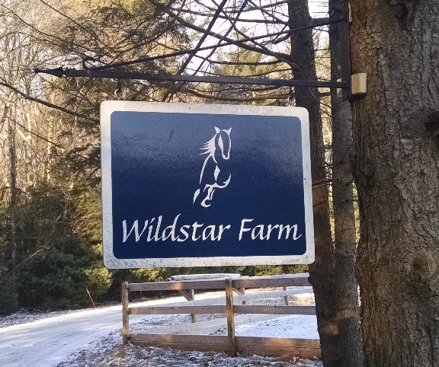

Sign states the name of the business; directly related to our commercial business, contributes to total number of signs, which exceeds what’s allowed by town bylaw.

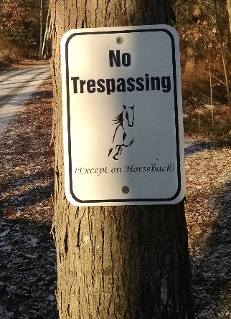

This sign is not an allowed type; contributes to total number of signs, which exceeds what’s allowed by town bylaw.

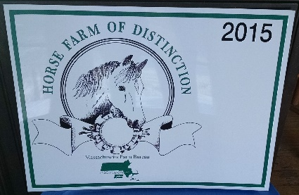

Size exceeds what’s allowed by town bylaw; directly related to our commercial business.