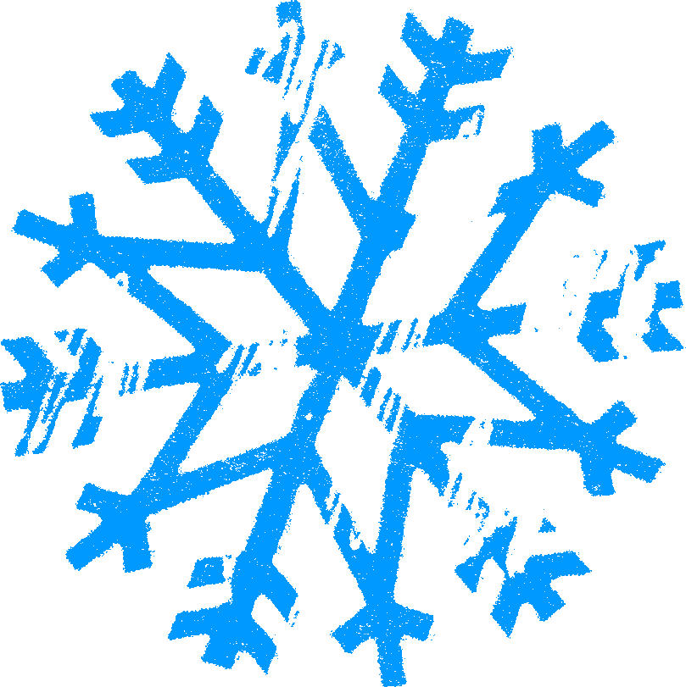 | To  Love,  Polly, Mike, Ben, & Brett |  | To  Love,  Polly, Mike, Ben, & Brett
 | To  Love,  Polly, Mike, Ben, & Brett |  | To  Love,  Polly, Mike, Ben, & Brett
 | To  Love,  Polly, Mike, Ben, & Brett |  | To  Love,  Polly, Mike, Ben, & Brett
 | To  Love,  Polly, Mike, Ben, & Brett |  | To  Love,  Polly, Mike, Ben, & Brett
 | To  Love,  Polly, Mike, Ben, & Brett |  | To  Love,  Polly, Mike, Ben, & Brett

